**Задание необходимо выполнить до *2025.01.27***

Вариант 1

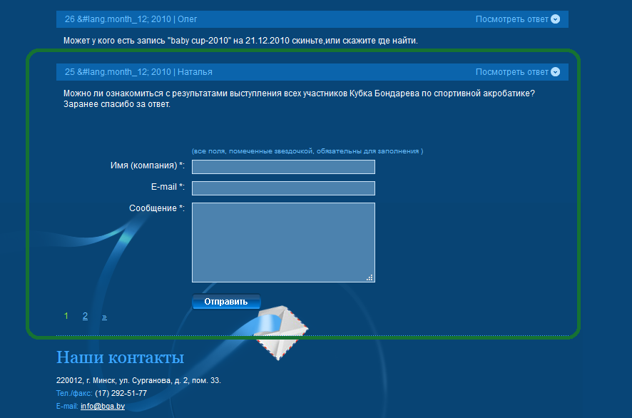http://bga.by/contacts

Вариант 2

<https://thinking-tester-contact-list.herokuapp.com/addUser>

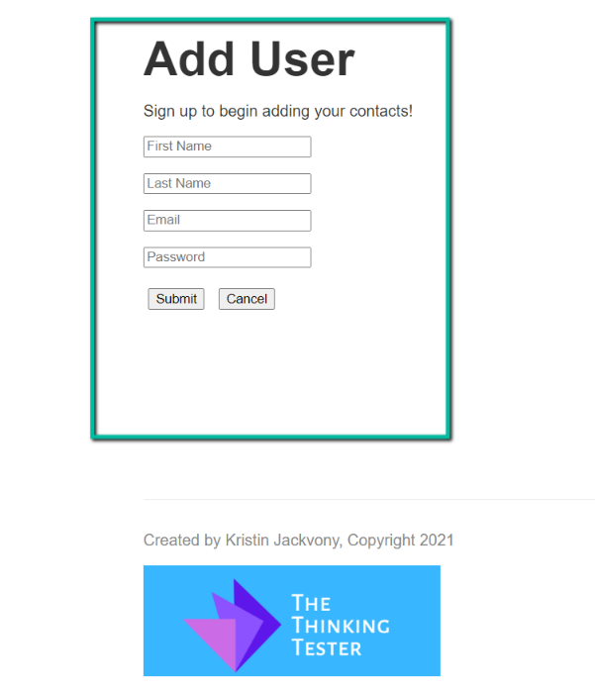

Вариант 3

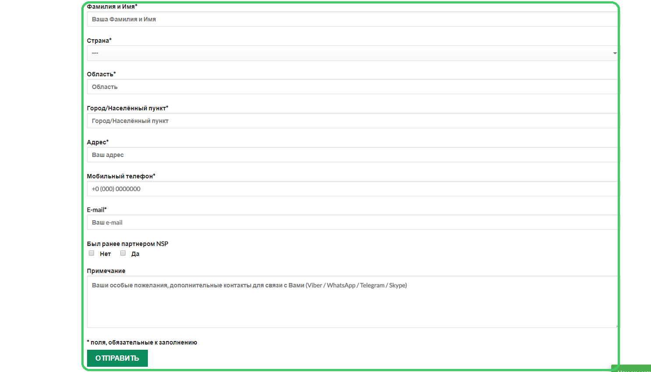https://nsp-24.com/kak-kupit-nsp/

<http://www.bga.by/rus/about/>

<https://thinking-tester-contact-list.herokuapp.com/addUser>

<https://nsp-24.com/kak-kupit-nsp/>

Задания:

1. Выбрать любой понравившийся вариант. Выйти на сайт по указанной ссылке
2. «Серфингуя» по страницам сайта, найти три дефекта и оформить соответствующие bug-reports
3. Воспользовавшись предоставленной картинкой выполнить мануальное тестирование зоны, расположенной внутри зеленой границы. Цель: составить и оформить test-cases
4. Среди созданных test-cases указать и выделить те, которые войдут в Ваш smoke- test
5. Язык выполнения заданий: английский
6. **Bug-report:**

|  |  |  |  |  |  |  |  |  |  |  |
| --- | --- | --- | --- | --- | --- | --- | --- | --- | --- | --- |
| **ID** | **Summary** | **Detailed Description** | **Steps to Reproduce** | **Reproducibility** | **Severity** | **Priority** | **Symptom** | **Workaround** | **Comment** | **Attachments** |
| 001 | Incorrect handling of empty fields on the registration page | On the registration page, if the "Name" and "Email" fields are left empty and the "Register" button is clicked, an error message does not appear | 1. Open the registration page. 2. Leave the "Name" and "Email" fields empty. 3. Click the "Register" button.  **Expected Result:** An error message should appear.  **Actual Result:** No error message appears. | Always | High | High | No error message when incorrect data is entered | No | Add field validation | Screenshots, if available. |
| 002 | Incorrect display of elements on mobile devices | When opening the site on a mobile device, some elements overlap each other on the main page | 1. Open the registration page. 2. Go to the main page. **Expected Result:** The elements are displayed correctly **Actual Result:** Some elements overlap each other | Always | Medium | Medium | Interface elements overlapping | No | Adapt CSS styles for mobile devices | Screenshots, if available. |
| 003 | Error while saving user data | While trying to save new user data, a "500 Internal Server Error" occurs | 1.Go to the add user page. 2. Fill in all fields with correct data. 3. Click the "Save" button.  **Expected Result:** User is successfully added. **Actual Result:** "500 Internal Server Error" | Always | High | High | Server error while saving data | No | Check server logs for error diagnosis | Screenshots, if available. |
| 004 | "Buy" button not working on the "How to Buy NSP" page | The "Buy" button on the https://nsp-24.com/kak-kupit-nsp/ page does not respond when clicked, and the order form page does not open | 1. Go to the https://nsp-24.com/kak-kupit-nsp/ page. 2. Click on the "Buy" button.  **Expected Result:** The order form page opens.  **Actual Result:** The button does not respond when clicked. | Always | High | High | Button does not perform its intended function | No | Check the JavaScript code related to the button. | Screenshots, if available. |
| 005 | Incorrect display of text on mobile devices | On the https://nsp-24.com/kak-kupit-nsp/ page, the text in the "Advantages" section overlaps images when viewed on mobile devices | 1. Open the https://nsp-24.com/kak-kupit-nsp/ page on a mobile device. 2. Scroll down to the "Advantages" section.  **Expected Result:** Text is displayed correctly without overlapping.  **Actual Result:** Text overlaps images. | Always | Medium | Medium | Incorrect display of content | No | Adapt the layout for mobile devices | Screenshots, if available. |

1. **Test-case:**

|  |  |  |  |  |  |  |
| --- | --- | --- | --- | --- | --- | --- |
| **ID** | **Name** | **Precondition** | **Steps** | **Expected Result** | **Actual Result** | **Status** |
| 001 | Entering valid data | Form page is open. | Enter valid data in the fields (Last Name, First Name, E-mail). Click the "CONTINUE" button. | Data is successfully saved | Data is successfully saved | Success |
| 002 | Entering empty values | Form page is open | Leave the fields in the form empty. Click the "CONTINUE" button. | Error message "Field is required" is displayed. | Error message "Field is required" is displayed. | Success |
| 003 | Email validation check | Form page is open. | Enter an invalid email (e.g., "abc@"). Click the "CONTINUE" button. | Error message "Invalid email address" is displayed. | Error message "Invalid email address" is displayed. | Success |
| 004 | Phone validation check | Form page is open. | Enter an invalid phone number (e.g., "123"). Click the "CONTINUE" button. | Error message "Invalid phone number" is displayed. | Error message "Invalid phone number" is displayed. | Success |

1. **Smoke-test:**

|  |  |  |  |  |  |  |
| --- | --- | --- | --- | --- | --- | --- |
| **ID** | **Name** | **Precondition** | **Steps** | **Expected Result** | **Actual Result** | **Status** |
| 001 | Entering valid data | The form page is open. | 1. Enter valid data into all mandatory text fields. 2. Select appropriate options from mandatory dropdown menus. 3. Check all required checkboxes. 4. Click the "CONTINUE" button. | The form processes the data successfully, and the system proceeds to the next step. | Data is successfully saved. | Success |